Izabelle Baldwin
Development Diary

Table of Contents
Version 1.0 2
Scaffolding: 2
Seeding users and roles: 2
Seeding suppliers and produce: 3
Suppliers 3
Produce 5
Plans for tomorrow: 5
Version 1.1 6
Add to Basket form: 6
Logic for adding items to a basket linked to the logged in user 7
Making the basket look nicer, adding total and loyalty discount: 8
Checkout function: 8
Checkout Button: 8
Checkout logic: 9
Checkout form: 9
JavaScript: 10
Plans for Tomorrow: 10
Version 1.2 11

Version 1.0
Today I created my project and all the models with the included views and controllers via scaffolding. I then seeded users and roles before creating default test user accounts, such as, Admin, Supplier, Standard and Developer. I then seeded the suppliers to allow users to view the different suppliers for the produce, as well as seeding the produce to link the two together. Users are able to login to the test accounts using the data provided and the login/register functions are fully functional.

Scaffolding:
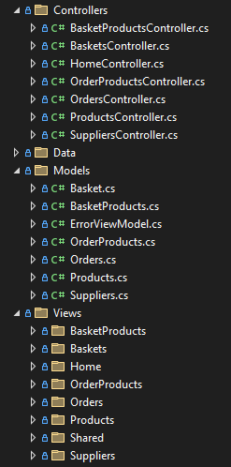

Seeding users and roles:
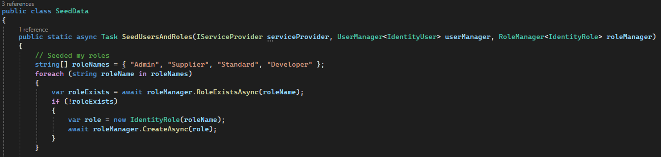
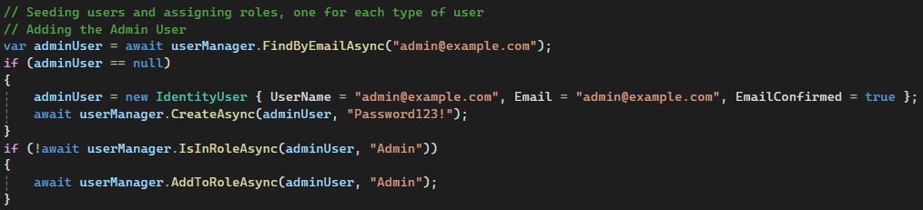
This is done for each role, Admin, Supplier (3 for security tests), Standard and Developer.

Seeding suppliers and produce:

Suppliers
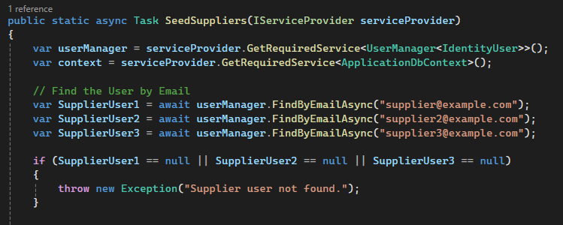
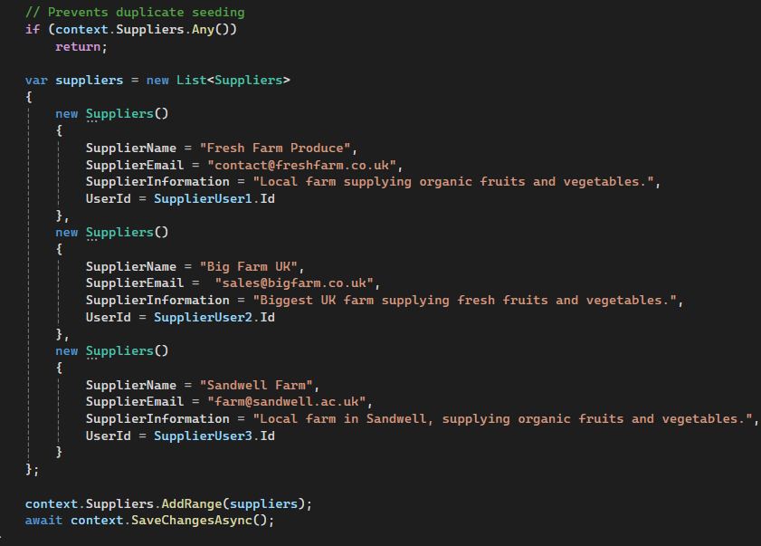
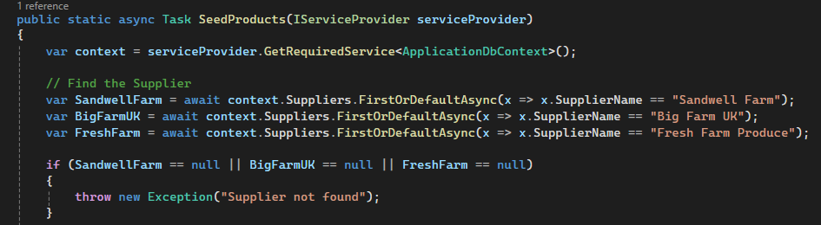

Produce
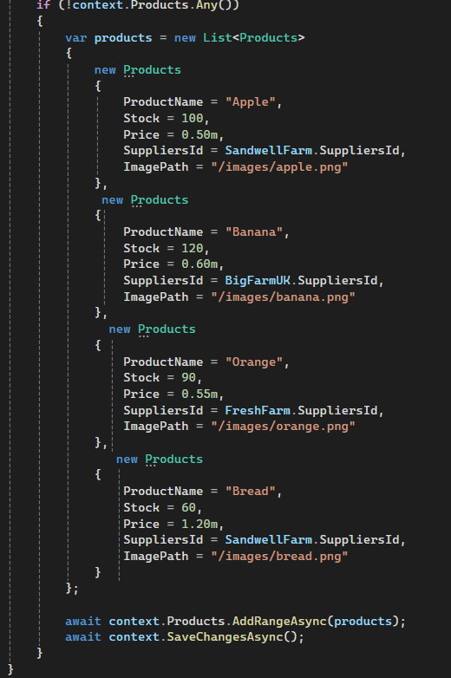

Plans for tomorrow:
Tomorrow I plan to create my first core function – adding products to the basket, I also plan to make the basket page look cleaner and I aim to link the basket to a specific user. As well as this I plan to, create the checkout function.

Version 1.1
Today I have managed to successfully create the basket function and made the basket display look more organised (not fully complete). The baskets are successfully linked to a user while also giving appropriate messages based on the basket status (if empty it tell the user, if there are items the user is given the option to checkout), I have also completed the checkout function which allows the user to choose between collection and delivery as well as further options depending on their choice.

Add to Basket form:
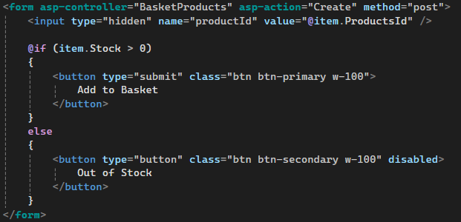

Logic for adding items to a basket linked to the logged in user
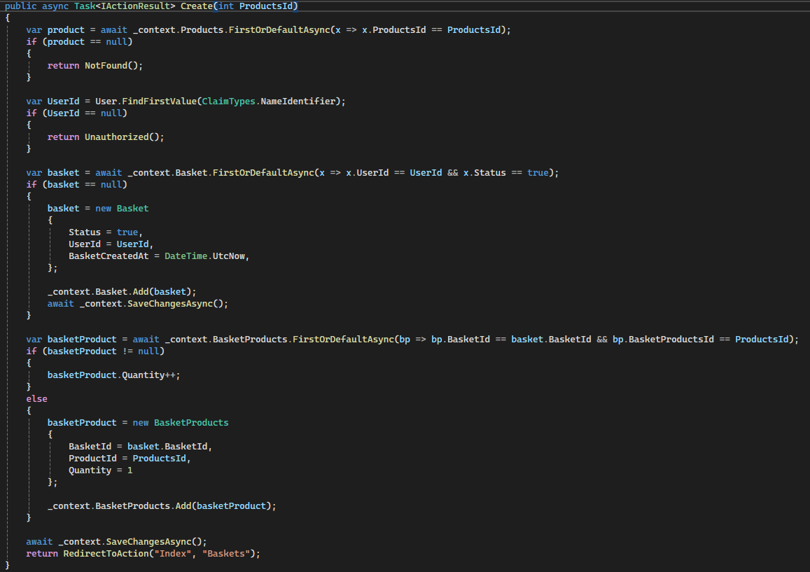

Making the basket look nicer, adding total and loyalty discount:
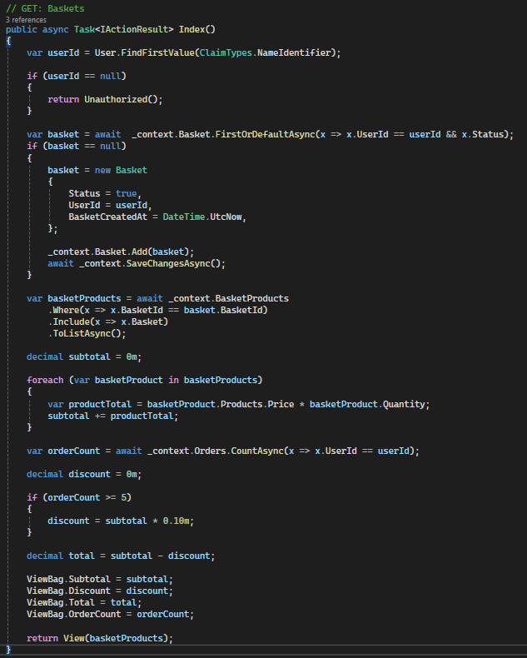

Checkout function:

Checkout Button:
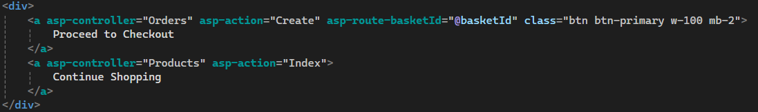

Checkout logic:
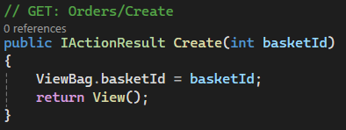

Checkout form:
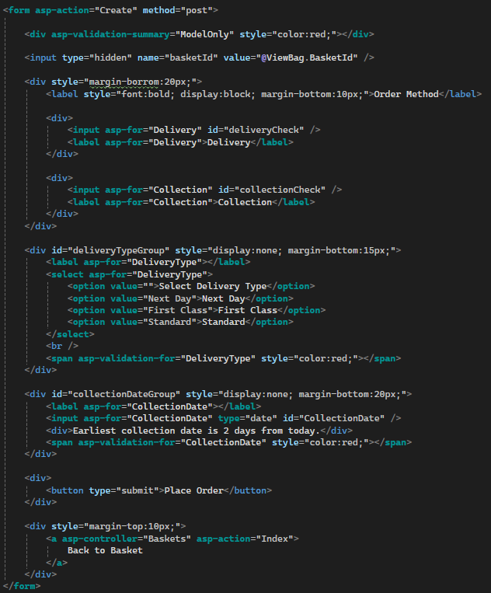

JavaScript:
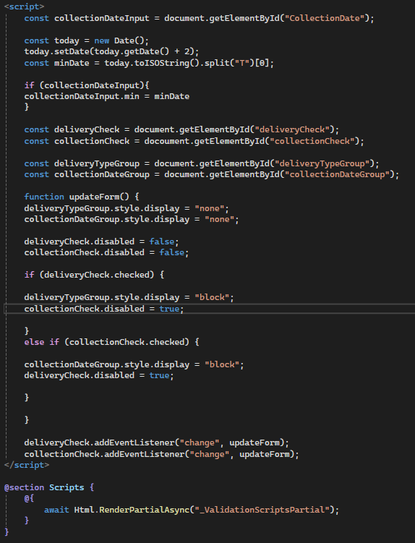

Plans for Tomorrow:
Tomorrow I plan to make the place order button functional, allowing for users to actually create an order. After this I hope to be able to allow users to view their orders (and make sure users can only view their own orders) and get a detailed breakdown of their order contents. I want to make it so that standard users can only view their own orders, bur suppliers can view all orders that contain their produce, and Admins should have permissions to view orders made by all users.

Version 1.2

